Table of Contents

Cloning a repository 2

Changing to respective task branch 2

Pulling code changes from main to task branch 2

Committing code changes 4

Merging codes to main branch 4

Approving pull request 6

# Cloning a repository

1. Open Git Bash (see [here](https://git-scm.com/downloads) to download).
2. Change the current working directory to the location where you want the cloned directory.

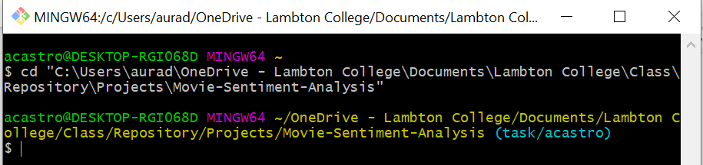

1. Type git clone, and then paste the URL.

git clone https://github.com/abccastro/Movie-Sentiment-Analysis.git

1. Press Enter to create your local clone.

Visual Studio Code will be used for demonstration

# Changing to respective task branch

Select (1) Source Control, then change the (2) main branch to your respective (3) task branch

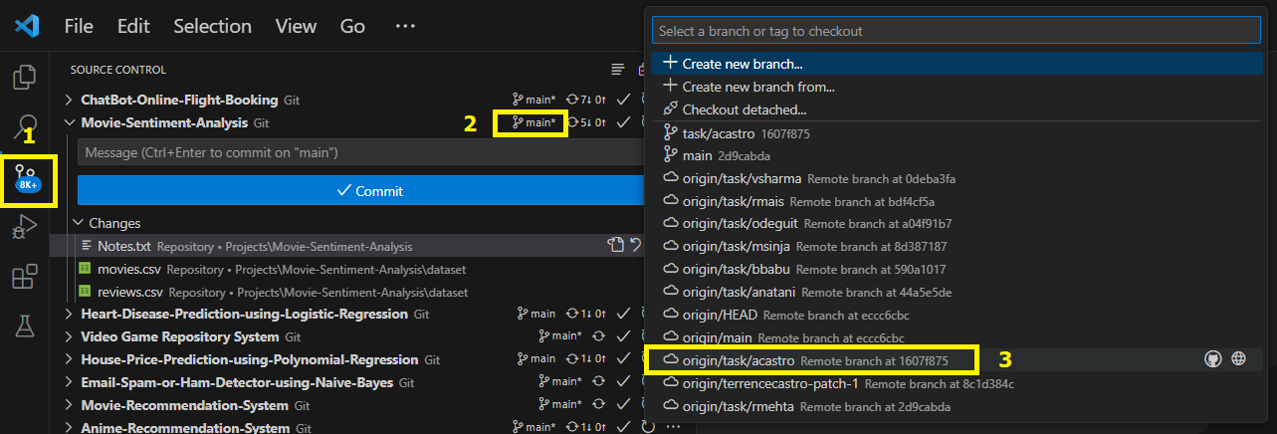

# Pulling code changes from main to task branch

Always get the recent changes from the main branch to update the codes in task branch **especially when planning to merge your codes changes to main branch.**

1. Click the ellipsis (…) beside the repository. Select **Pull, Push** then choose **Pull from** the origin/main.

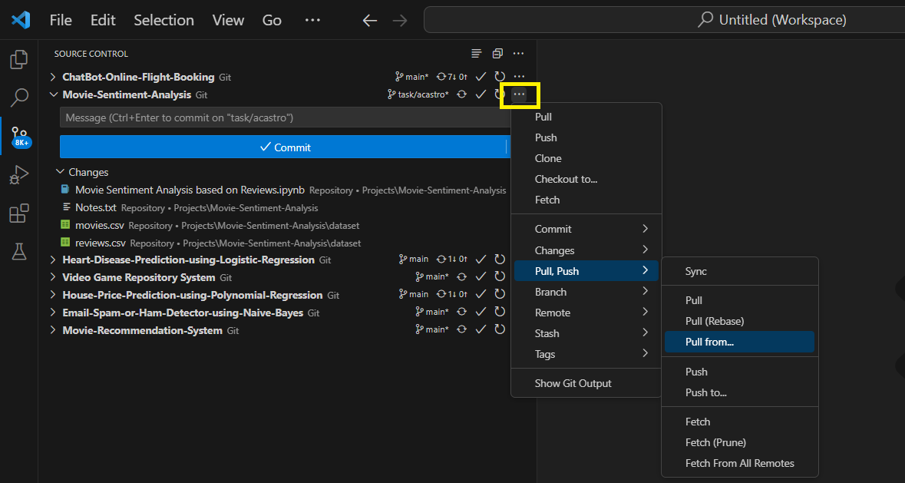

1. Resolve the code conflicts by manually revising the code. **Ensure to properly merge the codes, and only overwrite what's in the main branch if absolutely necessary.**

# Committing code changes

1. Click the (+) beside the file you want to stage.
2. The file should (2) be added in the **Staged Changes**.
3. Do not forget to add comments containing the summary of your changes.
4. Press the dropdown arrow on the Commit button, then select **Commit & Push**.

(*if you forgot to change to Commit & Push, you can click the ellipsis beside the repository, then select Push)*

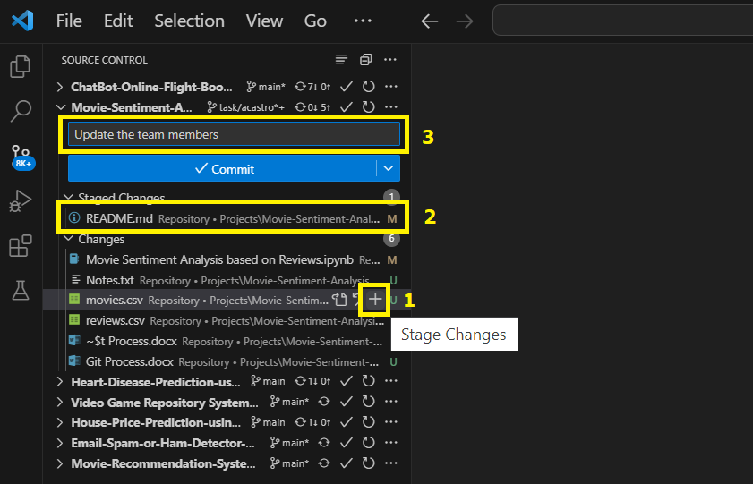

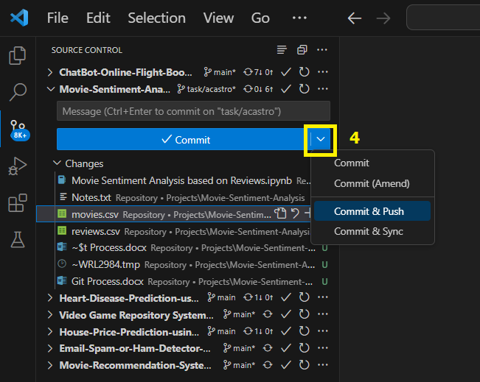

# Merging codes to main branch

1. Go to repository’s Pull Request tab: <https://github.com/abccastro/Movie-Sentiment-Analysis/pulls>, then click **New Pull Request**.

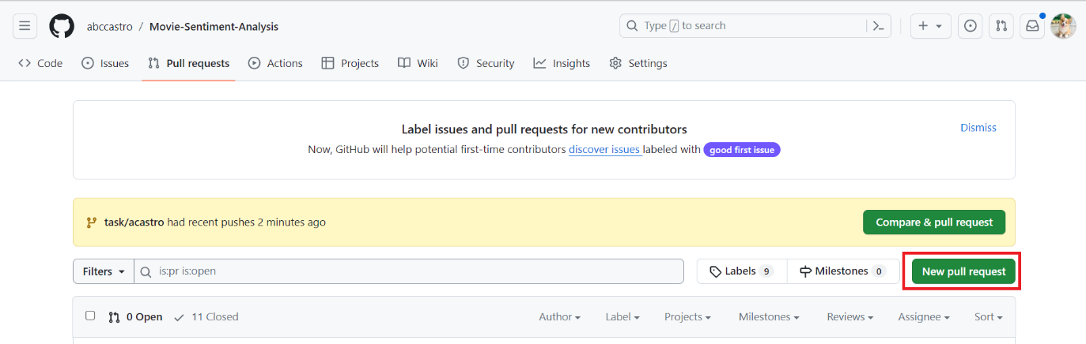

1. The **main** branch is the base branch. Change the compare branch to your (1) task branch before clicking the (2) **Create pull request**.

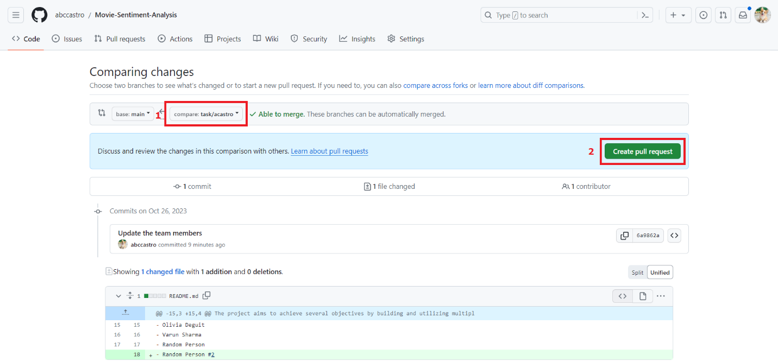

1. Add a comment on the pull request, if necessary, then click **Create pull request**.

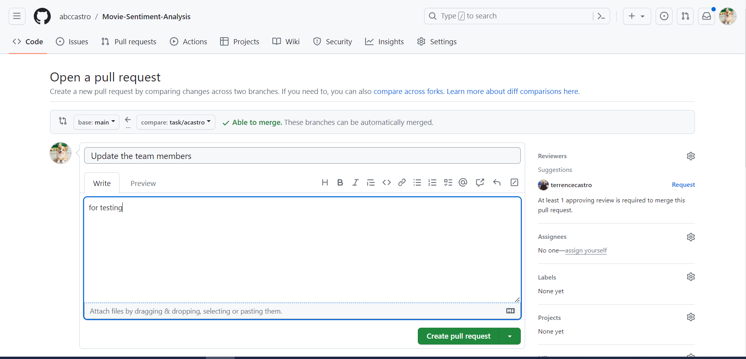

1. Ask another person to approve your pull request.

# Approving pull request

1. Go to repository’s Pull Request tab: <https://github.com/abccastro/Movie-Sentiment-Analysis/pulls>, then click the **Pull Request** created by other developer.

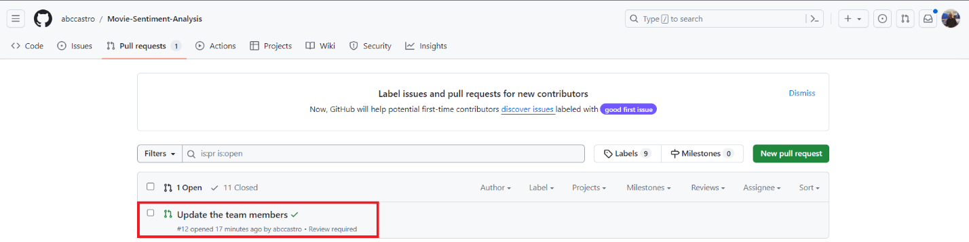

1. Click the **Add your review** beside Review required section

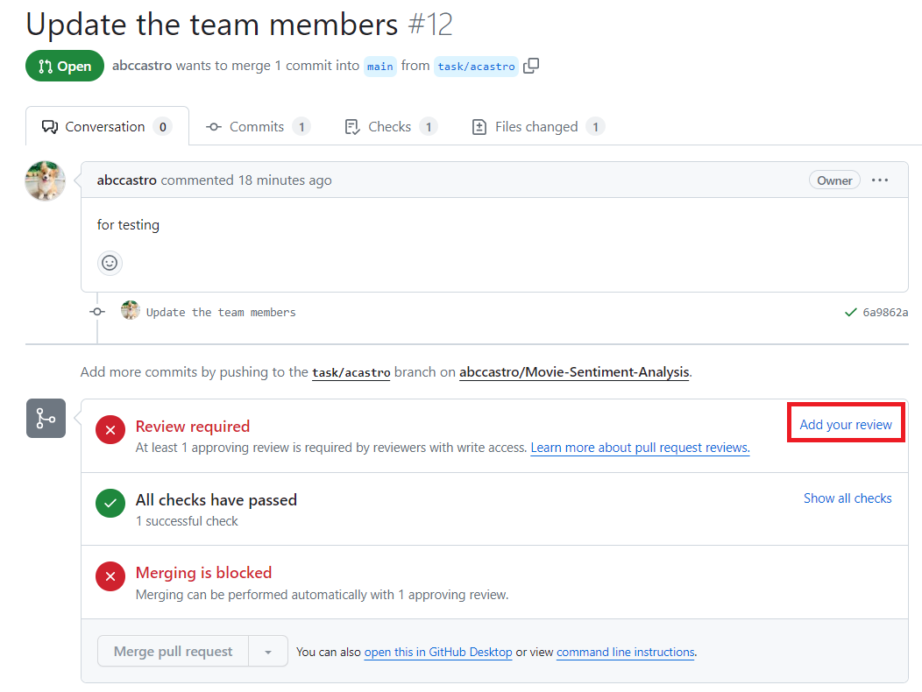

1. Review the code changes (highlighted in green for added codes, red for deleted codes). Make sure that the developer didn’t accidentally overridden existing codes unless there’s a reason for changing them. Click **Review changes**, then select the appropriate radio button.
2. **Comment:** general feedback with explicit approval
3. **Approve:** submit feedback and approve merging code changes
4. **Request changes:** submit feedback that must be addressed before merging

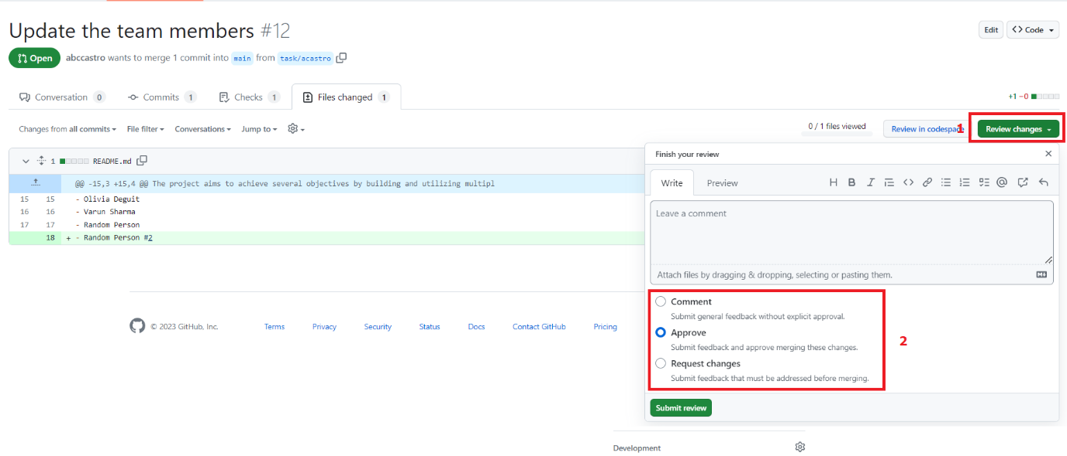

1. If approved, the **Merge pull request** button will be enabled. Either the approver or the developer can merge the codes. If successfully merged, all commits from the task branch will also reflect on the main branch.

If not approved, the developer needs to resolve first the issue before re-opening the same pull request.